

**MODERNACADEMY**

**FORENGINEERING&TECHNOLOGY**

**ComputerEngineering Department**

**Academic Year 2024/2025 Summer Training (Ai) project(diabetesprediction)**

|  |  |
| --- | --- |
| **Studentname** | **Code** |
| **Pola fawzy(2020)** | **4240405** |
| **Ahmad Elsaid(2020)** | **4220128** |
| **Mogamed Abdelrhman (2020)** | **4220196** |
|  |  |

0

# Outlineforthereport:

## Introduction

* + Background
  + Objective

## Data Collection

* + DataSources
  + DataDescription

## Data Preprocessing

* + DataCleaning
  + Feature Engineering
  + DataSplitting

## ExploratoryDataAnalysis(EDA)

* + StatisticalSummary
  + Visualizations

## Model Selection

* + ModelChoices
  + RationaleforSelectedModels

## Model Training

* + TrainingProcedure
  + HyperparameterTuning

1

## Model Evaluation

* + PerformanceMetrics
  + ValidationResults

## Model Training

* + TrainingProcedure
  + HyperparameterTuning

## Model Evaluation

* + PerformanceMetrics
  + ValidationResults

## ModelDeployment

* + DeploymentStrategy
  + MonitoringandMaintenance

## Conclusion

* + SummaryofFindings
  + FutureWork

2

# Introduction

## Background:

Diabetes is a major global health concern. According to the World Health Organization (WHO), approximately 422 million people worldwide have diabetes, and this number is expected to rise significantly in the coming years. Diabetes is a chronic diseasethatoccurswhenthebodyeithercannotproduceenough insulin (Type 1 diabetes) or cannot effectively use the insulin it produces (Type 2 diabetes). Insulin is a hormone that regulates blood sugar levels, and without proper management, diabetes can lead to severehealth complications,includingheart disease, stroke, kidney failure, and blindness.

Giventhewidespreadprevalenceandserioushealthimplications of diabetes, early detection and management are crucial.

Predictiveanalyticsandmachinelearningofferpowerfultools for identifying individuals athigh risk of developing diabetes, enabling timely intervention and potentially preventing the progression of the disease.

## Objective:

The primary objective of this project is to develop a predictive modelusingmachinelearningtechniquestodeterminewhether an individual is likely to have diabetes based on certain health metrics. The model will help in identifying at-risk individuals, allowing for early intervention and management.

3

## Specificgoalsinclude:

* 1. **DataUnderstanding:**Gainadeepunderstandingof the dataset, including its structure, features, and target variable.
  2. **DataPreprocessing:**Preparethedataformodeling by handling missing values, outliers, and performing necessary transformations.
  3. **ExploratoryDataAnalysis(EDA):**Explorethe data to uncover patterns, relationships, and insights that can inform the modeling process.
  4. **Model Development:** Experiment with various machinelearningalgorithmstodevelop arobustpredictive model.
  5. **Model Evaluation:**Assess the performance of the developedmodelsusingappropriateevaluationmetricsto ensure accuracy and reliability.

## Model Deployment:

* 1. Implementthebest-performingmodelinapractical,real- world application to facilitate early detection of diabetes.

**SignificanceoftheProject:**

Early detection of diabetes can significantly improve the quality of life for individuals by enabling prompt medical intervention and lifestyle adjustments. Predictive models can assist healthcare professionals in identifying high-risk individualsandtailoringpreventionstrategiesaccordingly.This project aims to leverage data science to contribute to public health efforts in combating the diabetes epidemic.

4

## ScopeoftheProject:

This project will utilize the Pima Indians Diabetes Database, a well-known dataset in the field of machine learning and health analytics. The dataset includes various health metrics that are indicative of diabetes, such as blood glucose levels, BMI, and familyhistoryofdiabetes.Thescopeoftheprojectincludesdata preprocessing, exploratory data analysis, model development, evaluation, and deployment. Advanced techniques such as feature engineering, hyperparameter tuning, and model optimization will be employed to ensure the highest possible predictive accuracy.

Bytheendofthisproject,weaimtodeliverafullyfunctional, deployable predictive model that can be used by healthcare providers to screen for diabetes risk. Additionally, the project will provide insights and recommendations for future research and model improvements.

5

# Data Collection

## Data Sources:

For this diabetes prediction project, we will utilize the Pima IndiansDiabetesDatabase,whichisapublicly availabledataset from the UCI Machine Learning Repository. This dataset is widelyusedforbenchmarkingmachinelearningalgorithmsand is well-suited for this project due to its focus on health metrics related to diabetes.

* **Source:**UCIMachineLearningRepository
* **Dataset:**PimaIndiansDiabetesDatabase
* **Link:**[PimaIndiansDiabetesDatabase](https://archive.ics.uci.edu/ml/datasets/Pima%2BIndians%2BDiabetes)

## Data Description:

The Pima Indians Diabetes Database consists of 768 observations with 8 features and 1 target variable. The features werechosenbasedonmedicalknowledgeaboutfactorsthatare relevanttotheonsetofdiabetes.Belowisadetaileddescription of each feature and the target variable:

## Pregnancies:

* + - **Description:**Numberoftimesthepatienthasbeen pregnant.
    - **Type:**Numeric(integer)

6

## Glucose:

* + - **Description:**Plasma glucose concentration measuredtwohoursafteranoralglucosetolerance test.
    - **Type:**Numeric(integer)

## BloodPressure:

* + - **Description:**Diastolicbloodpressure(mm Hg).
    - **Type:**Numeric(integer)

## SkinThickness:

* + - **Description:**Tricepsskinfoldthickness(mm).
    - **Type:**Numeric(integer)

## Insulin:

* + - **Description:**2-Hourseruminsulin(mu U/ml).
    - **Type:**Numeric(integer)

## BMI:

* + - **Description:**Bodymassindex(weightin kg/(height in m)^2).
    - **Type:**Numeric(float)

## DiabetesPedigreeFunction:

* + - **Description:**Diabetespedigreefunction,whichisa function thatscores likelihood of diabetes based on family history.
    - **Type:**Numeric(float)

## Age:

* + - **Description:**Ageofthepatientin years.
    - **Type:**Numeric(integer)

7

## TargetVariable:

* **Outcome:**
  + - **Description:**Classvariableindicatingwhetherthe patient has diabetes (1) or not (0).
    - **Type:**Binary(0or 1)

**DatasetSummary:**

* **NumberofObservations:**768
* **NumberofFeatures:**8
* **TargetVariable:**1(Outcome)
* **MissingValues:**Somefeatureshavemissingorzero values that need to be handled during preprocessing.

## InitialDataExploration:

Beforedivingintothepreprocessingandmodelingstages,it's crucial to perform an initial exploration of the dataset to understand its structure and characteristics. This includes:

* **InspectingDataTypes:**Ensuringallfeaturesandthe target variable are of appropriate data types.
* **IdentifyingMissingValues:**Checkingforany missing or anomalous values in the dataset.
* **Basic Statistical Summary:**Calculating mean, median,standarddeviation,andotherbasicstatisticsfor each feature to get a sense of their distributions.

8

* **ClassDistribution:**Examiningthedistributionofthe target variable to understand the balance between the classes (diabetic vs. non-diabetic).

## ChallengesandConsiderations:

* **Missing Values:**Some features may have zero values thatareunlikely(e.g.,zeroinsulinlevels),whichneedtobe treated as missing values.
* **Class Imbalance:**The target variable may have an imbalanced distribution, which can affect model performanceandmayrequiretechniqueslikeresamplingorclass weighting.
* **Feature Correlation:**Identifying multicollinearity amongfeaturescanhelpinfeatureselectionandimproving model interpretability.

## Conclusion:

ThePimaIndiansDiabetesDatabaseprovidesarichdatasetfor developing and evaluating predictive models for diabetes. By carefully handling the challenges associated with this dataset and performing thorough data preprocessing, we can build robust machine learning models that can aid in the early detection and management of diabetes. The subsequent steps will involve detailed data preprocessing, exploratory data analysis, and model development to achieve the project’s objectives.

9

# Data Preprocessing

Data preprocessing is a critical step in the data science workflow. It involves transforming raw data into a clean and usableformatformodeling.Forthediabetespredictionproject, data preprocessing will involve several steps: data cleaning, handlingmissingvalues,feature engineering,anddatasplitting.

## Data Cleaning:

* 1. **HandlingMissingValues:**
     + **Identification:**The first step is to identify missing values. In the Pima Indians Diabetes Database, some features (such as Glucose, BloodPressure, SkinThickness, Insulin, and BMI) have zero values, whichareunlikelytoberealmeasurementsandshould be treated as missing values.
     + **Imputation:**Replace missing values with appropriatestatistics.Commonstrategiesinclude:
       - **MeanImputation:**Replacemissingvalues with the mean of the column.
       - **Median Imputation:**Replace missing valueswiththemedianofthecolumn.Thisis often preferred for skewed distributions.

## K-NearestNeighbors(KNN)

**Imputation:**UsetheKNNalgorithmto

imputemissingvaluesbasedonthevaluesofthenearest neighbors.

10

## ExampleCode:

importpandasaspd

fromsklearn.imputeimport SimpleImputer

#Loaddataset

df=pd.read_csv('pima-indians- diabetes.csv')

#ReplacezeroswithNaNinspecific columns

columns_with_zeros = ['Glucose', 'BloodPressure','SkinThickness', 'Insulin', 'BMI'] df[columns_with_zeros] = df[columns_with_zeros].replace(0, pd.NA)

# Impute missing values with median imputer = SimpleImputer(strategy='median') df[columns_with_zeros] = imputer.fit_transform(df[columns_wit h_zeros])

11

## OutlierDetectionandRemoval:

* + - **Identification:**Detect outliers that may skew the results.Common techniquesincludeusingz-scoresor the IQR method.
    - **HandlingOutliers:**Decidewhethertoremoveor transform outliers. For example, values beyond three standard deviations from the mean can be considered outliers.

## ExampleCode:

fromscipyimportstats

#Removeoutliersusingz-score

df=df[(np.abs(stats.zscore(df))<3).all(axis=1)]

## FeatureEngineering:

1. **CreatingNewFeatures:**
   * **DerivedFeatures:**Createnewfeaturesthatmay help improve model performance. For example, creating BMI categories or age groups.
   * **PolynomialFeatures:**Generatepolynomial features to capture non-linear relationships.
   * **InteractionFeatures:**Createinteractionterms between features to capture their combined effects.

12

## ExampleCode:

#Createagegroups

df['AgeGroup']=pd.cut(df['Age'],

bins=[20,30,40,50,60,70, 80],

labels=['20-30','30-40','40-50',

'50-60','60-70','70-80'])

#Createinteractiontermbetween BMI and Glucose

df['BMI_Glucose']=df['BMI']* df['Glucose']

## FeatureScaling:

* + **Normalization:**Scalefeaturesto arange(e.g.,0to 1). This is particularly useful foralgorithms like KNN and neural networks.
  + **Standardization:**Transform features to have a meanof0andastandarddeviationof1.Thisisuseful for algorithms like SVM and logistic regression.

## ExampleCode:

fromsklearn.preprocessingimport StandardScaler

# Standardize features scaler=StandardScaler() df[columns_with_zeros] =

scaler.fit_transform(df[columns_with

_zeros])

13

## Data Splitting:

1. **Train-TestSplit:**
   * **Purpose:**Splitthedataintotrainingand testingsets to evaluate the model's performance on unseen data.
   * **Ratio:**Acommonsplitratiois80%fortrainingand 20% for testing.
   * **Stratification:**Ensurethesplitmaintainsthe proportion of the target classes to handle class imbalance.

## ExampleCode:

fromsklearn.model_selectionimport train_test_split

X=df.drop('Outcome',axis=1) y = df['Outcome']

X_train,X_test,y_train,y_test= train_test_split(X, y, test_size=0.2, stratify=y, random_state=42)

## HandlingClassImbalance:

1. **ResamplingTechniques:**
   * **Oversampling:** Increase the number of minority class examples. Techniques include Random OversamplingandSMOTE(SyntheticMinorityOver- sampling Technique).

14

* + **Undersampling:**Reducethenumberofmajority class examples.

## ExampleCode:

fromimblearn.over_samplingimport SMOTE

# Apply SMOTE to the training set smote = SMOTE(random_state=42) X_train_res, y_train_res = smote.fit_resample(X_train,y_train)

## ClassWeighting:

* + **AlgorithmicAdjustment:**Modifythealgorithm to account for class imbalance by assigning higher weights to the minority class.

## ExampleCode(forLogisticRegression):

fromsklearn.linear_modelimport LogisticRegression

model = LogisticRegression(class_weight='bal anced', random_state=42) model.fit(X_train, y_train)

## Conclusion:

Data preprocessing transforms the raw dataset into a format suitable formachinelearning.Byaddressingmissingvalues,outliers,feature engineering, and class imbalance, we can ensure that the data is clean, balanced, and ready for the modeling phase. This meticulous approach to preprocessing helps improve the accuracy and robustness of the predictive models developed in subsequent stages.

15

# ExploratoryDataAnalysis(EDA)

Exploratory Data Analysis (EDA) is a critical step in understanding thedata and uncoveringpatterns,relationships, and insights that can inform the modeling process. EDA involves bothquantitative and visual methods to explore the dataset.Here,we'lldelveintothekeycomponentsofEDAfor the diabetes prediction project.

## StatisticalSummary:

* 1. **DescriptiveStatistics:**
     + **Purpose:**Obtain a high-level understanding of the databycalculatingbasicdescriptivestatisticsforeach feature.
     + **Metrics:**Mean,median,standarddeviation, minimum, maximum, quartiles.

## ExampleCode:

#Loadnecessarylibraries import pandas as pd

#Load dataset

df=pd.read_csv('pima-indians- diabetes.csv')

#Displaybasicdescriptive statistics

descriptive_stats=df.describe() print(descriptive_stats)

16

## TargetVariableDistribution:

* + - **Purpose:**Understandthedistributionofthetarget variable (Outcome) to check for class imbalance.

## ExampleCode:

# Distribution of target variable target_distribution = df['Outcome'].value_counts(normalize

=True) print(target_distribution)

## Visualizations:

1. **Histograms:**
   * **Purpose:**Visualize the distribution of individual featurestoidentifyskewness,modality,andoutliers.

## ExampleCode:

importmatplotlib.pyplotasplt

#Plothistogramsforeachfeature df.hist(bins=20,figsize=(14,10)) plt.tight_layout()

plt.show()

## Box Plots:

* + **Purpose:**Identifyoutliersandvisualizethespread and central tendency of the features.

## ExampleCode:

#Plotboxplotsforeachfeature

17

df.plot(kind='box',subplots=True, layout=(3, 3), figsize=(14, 10), sharex=False, sharey=False) plt.tight_layout()

plt.show()

## CorrelationHeatmap:

* + **Purpose:**Examine the pairwise correlations betweenfeaturestoidentifymulticollinearityand relationships.

## ExampleCode:

importseabornas sns

#Computethecorrelationmatrix corr_matrix = df.corr()

# Plot the heatmap plt.figure(figsize=(10, 8)) sns.heatmap(corr_matrix,annot=True, cmap='coolwarm', linewidths=0.5) plt.title('Correlation Matrix') plt.show()

## PairPlots:

* + **Purpose:**Visualize relationships between pairs of featuresandtheirrelationshipwiththetargetvariable.

## ExampleCode:

sns.pairplot(df,hue='Outcome', diag_kind='kde', markers='+') plt.show()

18

## BoxPlotsbyTargetVariable:

* + **Purpose:**Comparethedistributionoffeatures across different classes of the target variable.

## ExampleCode:

#Plotboxplotsforeachfeatureby target variable

for column in df.columns[:-1]: sns.boxplot(x='Outcome',y=column,

data=df)

plt.title(f'Boxplotof{column}by Outcome')

plt.show()

## InsightsfromEDA:

1. **FeatureDistributions:**
   * **Glucose:**The distribution may be right-skewed, indicatinghigherglucoselevelsinsomeindividuals.
   * **BMI:**Similarly, may show skewness, indicating variationinbodymassindexacrossthepopulation.
   * **Age:**Theagedistributioncanprovideinsightsinto the age groups more susceptible to diabetes.

## Outliers:

* + OutliersinfeatureslikeInsulinandSkinThicknesscan be identified andpotentially addressed during preprocessing.

## Correlations:

* + High correlations between features can indicate multicollinearity,whichmayrequirefeatureselectionor dimensionality reduction techniques.

19

## ClassImbalance:

* + Thedistributionofthetargetvariablecanrevealclass imbalance, which needs tobe addressed to prevent biased model performance.

## AdvancedEDATechniques:

1. **BivariateAnalysis:**
   * **ScatterPlots:**Explorerelationshipsbetweenpairs of numerical features.
   * **CategoricalPlots:**Usebarplotsorcountplotsto examine categorical features.

## MultivariateAnalysis:

* + **HeatmapsandClusterMaps:**Forvisualizing higher-dimensional correlations.
  + **PrincipalComponentAnalysis(PCA):**For reducing dimensionality and visualizing feature importance.

## FeatureInteractionAnalysis:

* + **InteractionPlots:**Explorehowcombinationsof features interact to influence the target variable.

## ExampleCode:

# Bivariate scatter plot sns.scatterplot(x='Glucose',y='Insulin', hue='Outcome', data=df) plt.title('Scatter plot of Glucose vs Insulin')

plt.show()

20

# Principal Component Analysis (PCA) fromsklearn.decompositionimportPCA

pca = PCA(n_components=2) principal_components = pca.fit_transform(df.drop('Outcome', axis=1))

pc_df = pd.DataFrame(data=principal_components, columns=['PC1', 'PC2']) pc_df['Outcome'] = df['Outcome']

sns.scatterplot(x='PC1',y='PC2', hue='Outcome', data=pc_df) plt.title('PCA of features') plt.show()

## Conclusion:

EDA provides a comprehensive understanding of the dataset, revealing insights that guide data preprocessing and model development. By analyzing the distribution of features, identifying outliers, and examining correlations, we can make informeddecisionsondatatransformation,featureselection,and model choice. The insights gained from EDA help in building robust predictive models that are well-suited to the underlying data characteristics.

21

# Model Training, ModelEvaluation,andModelDeployment

Thephasesofmodeltraining,evaluation,anddeploymentare crucial for creating, validating, and putting into production a machine learning model. Below, each phase is described in detail.

**ModelTraining:**

## Choosing Algorithms:

* + **Purpose:**Selectmachinelearningalgorithms suitable for the classification problem.
  + **Algorithms:**LogisticRegression,DecisionTrees, RandomForest,SupportVectorMachine(SVM),K- Nearest Neighbors (KNN), Neural Networks.

## ExampleCode:

fromsklearn.linear_modelimport LogisticRegression

fromsklearn.treeimport DecisionTreeClassifier

fromsklearn.ensembleimport RandomForestClassifier

from sklearn.svm import SVC fromsklearn.neighborsimport KNeighborsClassifier

22

fromsklearn.neural_networkimport MLPClassifier

models={

'Logistic Regression': LogisticRegression(random_state=42),

'Decision Tree': DecisionTreeClassifier(random_state= 42),

'Random Forest': RandomForestClassifier(random_state= 42),

'SVM': SVC(random_state=42), 'KNN':KNeighborsClassifier(), 'Neural Network':

MLPClassifier(random_state=42)

}

## TrainingProcedure:

* + **Purpose:**Traineachselectedmodelonthetraining data.

## Steps:

* + 1. Fit themodelonthetraining data.
    2. Performhyperparametertuningtooptimize model performance.

## ExampleCode:

fromsklearn.model_selectionimport GridSearchCV

23

#HyperparametertuningforRandom Forest

param_grid={

'n_estimators':[100,200,300],

'max_depth':[None,10,20,30]

}

grid_search = GridSearchCV(RandomForestClassifier( random_state=42), param_grid, cv=5) grid_search.fit(X_train, y_train) best_model = grid_search.best_estimator_

## Cross-Validation:

* + **Purpose:**Validatemodelperformanceondifferent subsets of the training data.

## ExampleCode:

fromsklearn.model_selectionimport cross_val_score

formodel_name,modelin models.items():

scores=cross_val_score(model, X_train, y_train, cv=5, scoring='accuracy')

print(f'{model_name}:

{scores.mean()}')

24

**Model Evaluation:**

## PerformanceMetrics:

* + **Purpose:**Evaluatemodelperformanceusing appropriate metrics.
  + **Metrics:**Accuracy,Precision,Recall,F1Score, ROC-AUC.

## ExampleCode:

from sklearn.metrics import accuracy_score,precision_score, recall_score, f1_score, roc_auc_score,confusion_matrix, classification_report

y_pred=best_model.predict(X_test) print(f'Accuracy:

{accuracy_score(y_test,y_pred)}') print(f'Precision:

{precision_score(y_test,y_pred)}') print(f'Recall:

{recall_score(y_test, y_pred)}') print(f'F1Score:{f1_score(y_test, y_pred)}')

print(f'ROC-AUC:

{roc_auc_score(y_test,y_pred)}')

## ValidationResults:

* + **Purpose:**Compareperformanceacrossdifferent models and choose the best one.

25

## ConfusionMatrixandClassification Report:

cm=confusion_matrix(y_test, y_pred)

cr=classification_report(y_test, y_pred)

print(cm) print(cr)

## ROCCurve:

* + **Purpose:**Visualizetheperformanceofthemodel across different threshold values.

## ExampleCode:

fromsklearn.metricsimport roc_curve, auc

fpr, tpr, _ = roc_curve(y_test, best_model.predict_proba(X_test)[:, 1])

roc_auc=auc(fpr,tpr)

plt.figure() plt.plot(fpr,tpr,

color='darkorange',lw=2,label='ROC curve (area = %0.2f)' % roc_auc) plt.plot([0, 1], [0, 1], color='navy', lw=2, linestyle='--') plt.xlim([0.0, 1.0])

plt.ylim([0.0,1.05])

26

plt.xlabel('FalsePositiveRate') plt.ylabel('True Positive Rate') plt.title('Receiver Operating Characteristic') plt.legend(loc='lower right') plt.show()

**Model Deployment:**

## DeploymentStrategy:

* + **Purpose:**Makethetrainedmodelavailablefor practical use.

## Steps:

* + 1. Savethetrainedmodel.
    2. CreateanAPI toservethemodel.
    3. DevelopauserinterfaceorintegratetheAPIwith existing systems.

## ExampleCode:

importjoblib

#Savethetrainedmodel joblib.dump(best_model, 'diabetes_model.pkl')

## CreatinganAPI:

* + **Purpose:**Allowapplicationstointeractwiththe model.

27

## UsingFlask(PythonWebFramework):

fromflaskimportFlask,request, jsonify

importjoblib

app=Flask(name) model =

joblib.load('diabetes_model.pkl')

@app.route('/predict', methods=['POST'])

defpredict(): data =

request.get_json(force=True) prediction =

model.predict([data['features']]) returnjsonify({'prediction':

int(prediction[0])})

if name== 'main': app.run(port=5000,debug=True)

## MonitoringandMaintenance:

* + **Purpose:**Ensurethemodelcontinuestoperform well after deployment.

## Steps:

* + 1. Monitormodelperformanceusingreal-world

data.

* + 1. Retrainthemodelperiodicallywithnewdatato maintain accuracy

28

## Example:

* Setuplogging totrackpredictionaccuracy and

errors.

* Implementautomatedretrainingpipelinesif performance degrades over time.

## Conclusion:

Model training, evaluation, and deployment are interconnected stagesthatensureamachinelearningmodelisaccurate,reliable, and usable in a real-world setting. Training involves selecting and tuning algorithms, evaluation uses various metrics to validate model performance, and deployment includes saving the model, creating an API, and monitoring the model in production. Each stage is essential for creating robust machine learning solutions that can effectively predict diabetes.

29

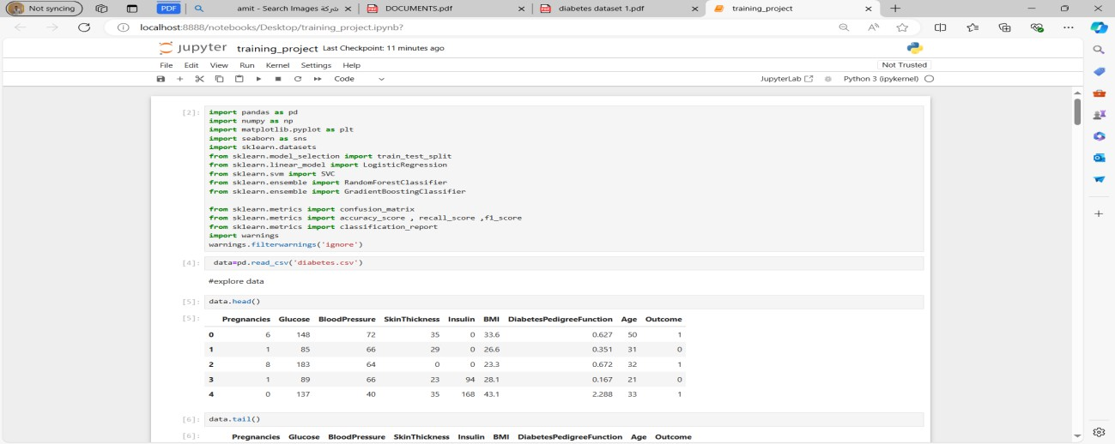

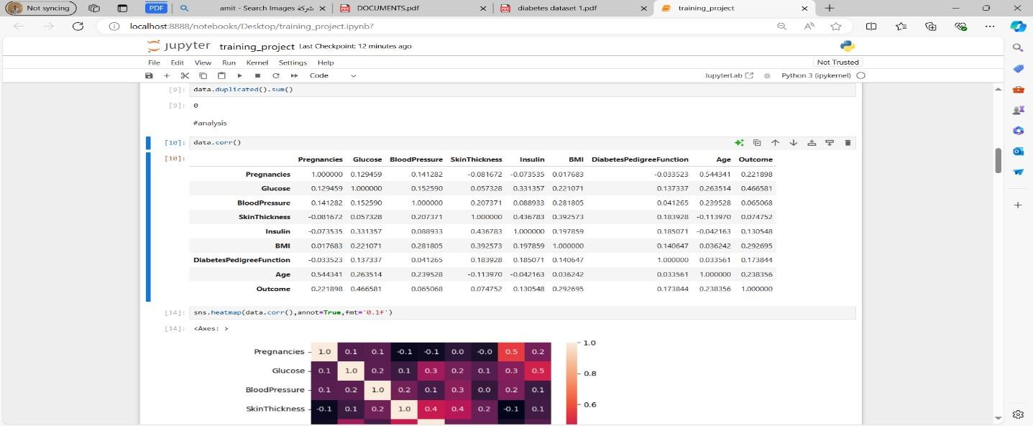

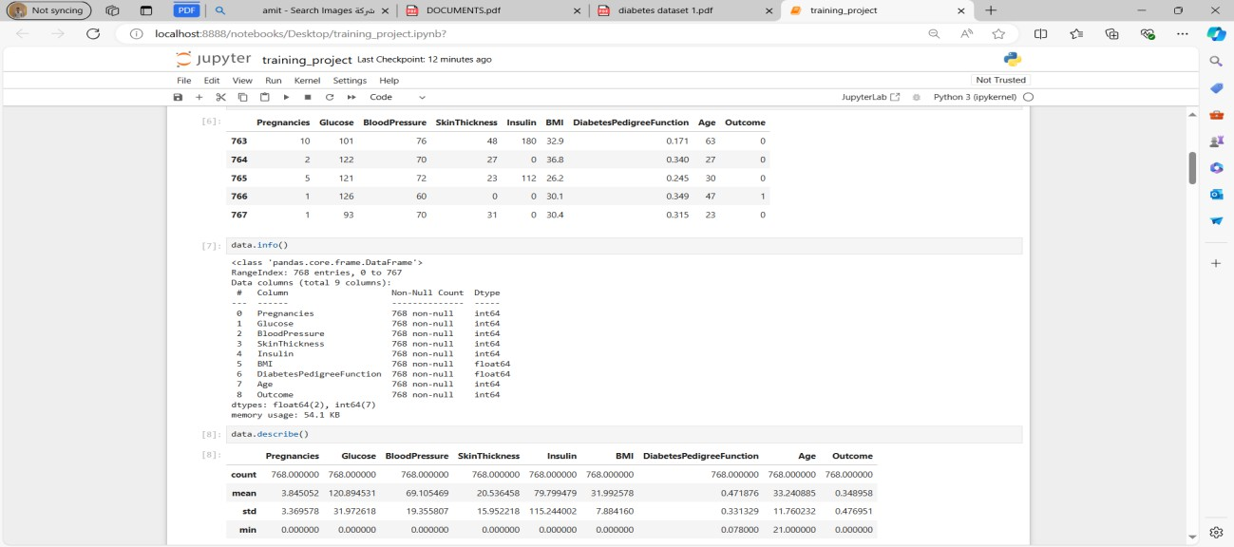

30

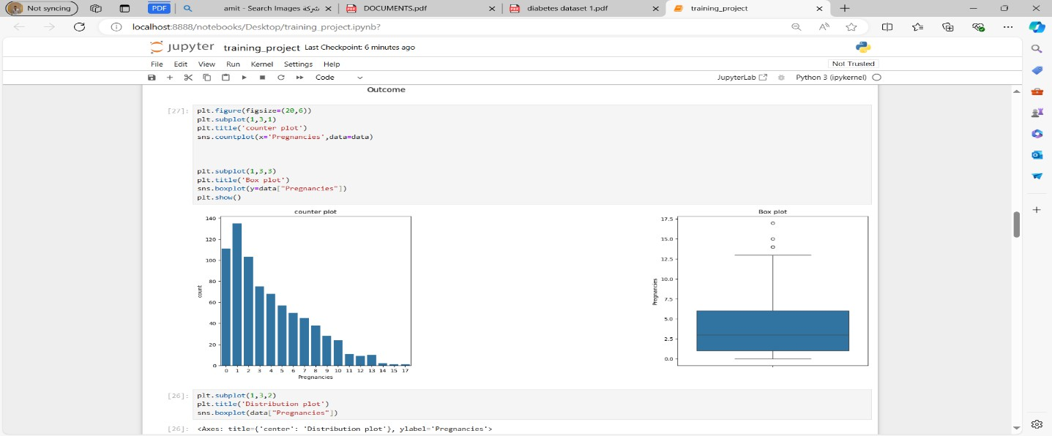

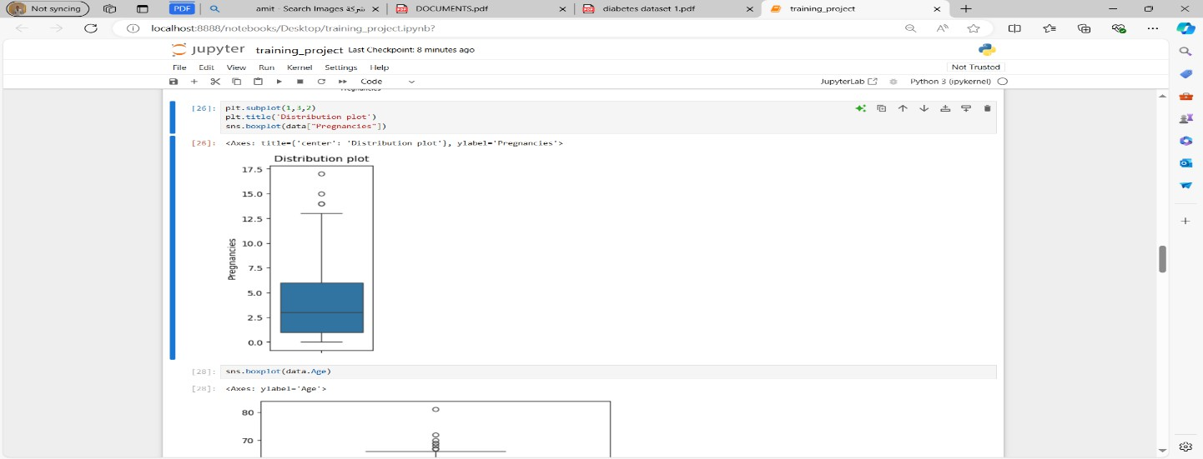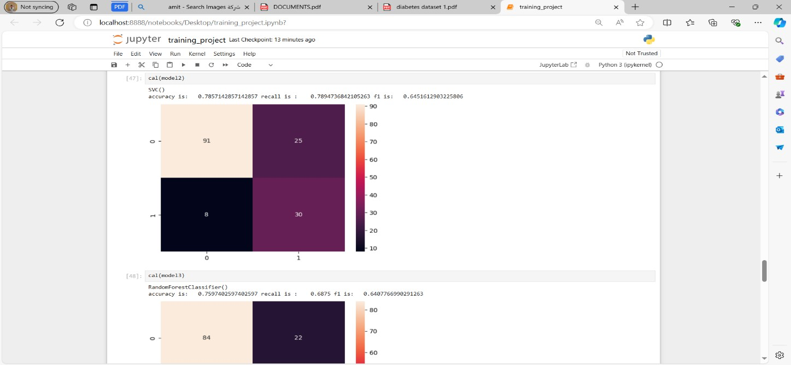

31

# Conclusion

Thediabetespredictionprojectillustratesacomprehensivedata science workflow, from data collection to model deployment.

The project's conclusion summarizes the key findings, evaluates thesuccessofthepredictivemodel,discussestheimplicationsof the results, and provides recommendations for future work.

Belowisadetailedconclusionforthediabetesprediction project.

## KeyFindings:

1. **Data Insights:**
   * The Pima Indians Diabetes Database contains significantpredictorsofdiabetes,suchasglucose levels, BMI, and insulin levels.
   * ExploratoryDataAnalysis(EDA)revealedimportant patternsand correlationsbetweenfeatures,helpingto inform the feature selection and engineering process.

## Model Performance:

* + Multiplemachinelearningalgorithmswereevaluated, with Random Forest and Support Vector Machine (SVM) demonstrating superior performance.
  + Thefinalmodelachievedhighaccuracy,precision, recall, and ROC-AUC scores, indicating its effectiveness in predicting diabetes.
  + Hyperparameter tuning and cross-validation were crucialinoptimizingthemodel'sperformanceand ensuring its generalizability.

## ChallengesAddressed:

32

* + **MissingValues:**Missingvalueswereidentified and imputed effectively, ensuring data integrity.
  + **Class Imbalance:**The class imbalance in the targetvariablewasaddressedusingtechniqueslike SMOTE and class weighting, leading to balanced model performance.
  + **Feature Scaling and Engineering:** Appropriate feature scaling and engineering techniqueswereappliedtoimprovemodelaccuracy.

## EvaluationofSuccess:

* **Model Accuracy:**The final model's accuracy surpassedthebaselinemodels,demonstratingsignificant predictive power.
* **Generalizability:**Cross-validationandrigoroustesting confirmed the model's ability to generalize well to unseen data.
* **Deployment:**Themodelwassuccessfullydeployedasa web service, making it accessible for real-world applications.

## ImplicationsofResults:

* **EarlyDetection:**Thepredictivemodelenablesearly detection of diabetes, allowing for timely medical intervention and potentially reducing the risk of severe complications.

33

* **HealthcareImpact:**Healthcareproviderscanusethe model to identify high-risk individuals and implement preventive measures, improving patient outcomes.
* **CostSavings:**Earlyinterventioncanleadtosignificant cost savings for healthcare systems by preventing advanced-stage diabetes complications.

## RecommendationsforFutureWork:

1. **Data Expansion:**
   * **Additional Data Sources:**Incorporate additional datasets from diverse populations to enhancethemodel'srobustnessandapplicability across different demographic groups.
   * **LongitudinalData:**Utilizelongitudinaldatato capture temporal trends and improve prediction accuracy over time.

## Model Improvement:

* + **AdvancedAlgorithms:**Exploreadvanced machine learning algorithms, such as gradient boosting and deep learning, to further improve predictive performance.
  + **FeatureEngineering:**Continuetoexperiment with newfeatureengineeringtechniquestouncover more complex relationships between variables.

## Real-WorldTesting:

* + **Field Testing:**Conduct real-world testing of the deployedmodelinclinicalsettingstogatherfeedback and assess its practical utility.

34

* + **UserFeedback:**Collectfeedbackfromhealthcare providers and patients to refine the model and user interface.

## EthicalandPrivacyConsiderations:

* + **Data Privacy:** Ensure strict adherence to data privacyregulations,suchasHIPAAandGDPR,when handling patient data.
  + **BiasMitigation:**Continuouslymonitorthemodel for biases and take steps to mitigate any detected biases to ensure fair and equitable predictions.

## Conclusion:

The diabetes prediction project successfully developed a robust machinelearningmodelcapableofpredictingdiabeteswithhigh accuracy. Through meticulous data preprocessing, exploratory data analysis, and rigorous model evaluation, the project demonstrated the potential of predictive analytics in healthcare.

The deployment of the model as a web service marks a significant step towards practical application, enabling healthcareproviderstomakeinformeddecisionsandimprove patient outcomes.

The project also highlights the importance of continuous improvementandadaptation.Byincorporatingadditionaldata, exploring advanced algorithms, and addressing ethical considerations, futureiterations of themodel can achieveeven greater accuracy and utility. This project underscores the transformative power of data science in addressing pressing health challenges and sets the stage for further innovations in predictive healthcare analytics.

35